https://github.com/suvashsumon/WEB-ENGINEERING-LAB-SOLUTION

https://github.com/ahnafshahrear/Bookshop-Management-System

<https://github.com/ahnafshahrear/Employee-Information-System>.

<https://github.com/null0ptr/laravel-basic>

<https://github.com/Munawertaj/Employee>

<https://github.com/esnayem/Employee-Information-System>

<https://github.com/Sritycseru/Employee_Management_System/tree/main/practice1>

https://github.com/Ankar-Kumar/lab

# **Web Engineering Lab (B.Sc Engg Part-4, 2021)**

Create an Employee Information System using the Laravel web framework. You can find the

initial project in the following GitHub repository.

|  |
| --- |
| <https://github.com/m-r-kushal/lab4222_23_g1.git> |

## **Objective 1**

Clone the repository to your computer and place it in your webroot folder. Take necessary

steps to make the initial application up and running. (E.g., create a MySQL database for the

application, update environment variables in the .env file, install project dependencies).

Finally, visit the web application's root URL and show the home page.

Solution: When you clone a Laravel project from GitHub, you'll need to set it up on your local environment before you can run it. Here's a step-by-step guide:

(Note: you must install Laragon, Composer, and npm first)

1. Clone the Repository  
   git clone <project-url>

1. Navigate to the Project Folder  
   cd <project-folder>

1. Install PHP Dependencies  
   composer install

1. Install Node.js Dependencies  
   npm install

1. Set Up Environment Configuration  
   cp .env.example .env

This copies the example environment file (.env.example) to a new .env file, which will store the project's environment-specific settings.

1. Generate Application Key  
   php artisan key:generate

This generates a unique application key and adds it to the .env file. The key is used for encryption and other security-related tasks in Laravel.

1. Start the Development Serve

php artisan serve

By default, the project should now be accessible at <http://localhost:8000>.

## **Objective 2**

Create a new git branch named dev and generate migration and seeder classes to create a

table for employee information following the Laravel naming convention and insert test data.

Table attributes:

* id (primary key)
* name (string:255)
* job_title (string:100)
* joining_date (date)
* salary (float)
* email (string:255, optional)
* mobile_no (string)
* address(text)

Solution: To generate migration and seeder classes, you should first create a database using phpmyadmin, HeidiSQL, or any other database client.

1. Put the database name, username, and password  in the env folder like this:

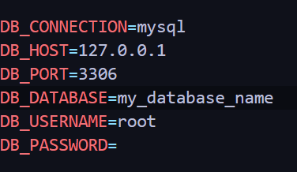

1. Generate a Migration with model, controller, factory, and seeder. When you create these together, these are automatically connected.

Note: If you create one by one then you need to connect the model, migration, and factory manually. (Not recommended)

Single Command to Generate Everything You Need:  
php artisan make:model <ModelName> -mcrfs

<ModelName>: Replace this with the name of your model, typically in singular form (example: Employee).

-m: Generates a migration file along with the model. This file will be located in the database/migrations directory.

-c: Creates a controller for the model. This will be placed in the app/Http/Controllers directory.

-r: Indicates that the controller should be a resource controller, which includes methods for handling typical CRUD operations (index, create, store, show, edit, update, destroy).

-f: Generates a factory for the model, placed in the database/factories directory. Factories are useful for generating test data.

-s: Creates a seeder for the model, found in the database/seeders directory. Seeders are used to insert data into the database.

1. Define the Table Structure

* Open the generated migration file located in the database/migrations directory.
* In the up() method, define the columns of the table:

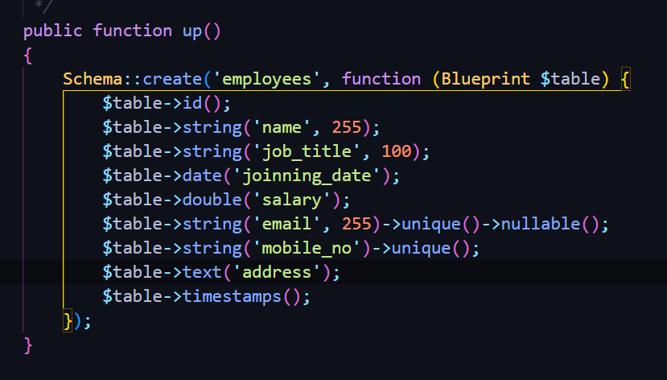

1. Run the Migration  
   php artisan migrate

This command connects to your configured database server (as specified in the .env file) and updates the database by applying the changes defined in the migration files.

1. Go to the EmployeeFactory file from database/factories and update the file to generate test data

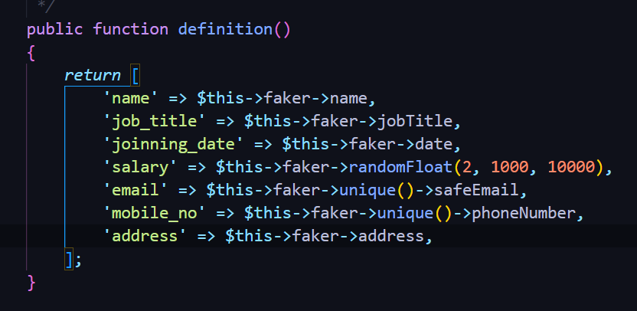

1. Goto EmployeeSeeder file from database/seeders and update the file to run the factory in the seeder

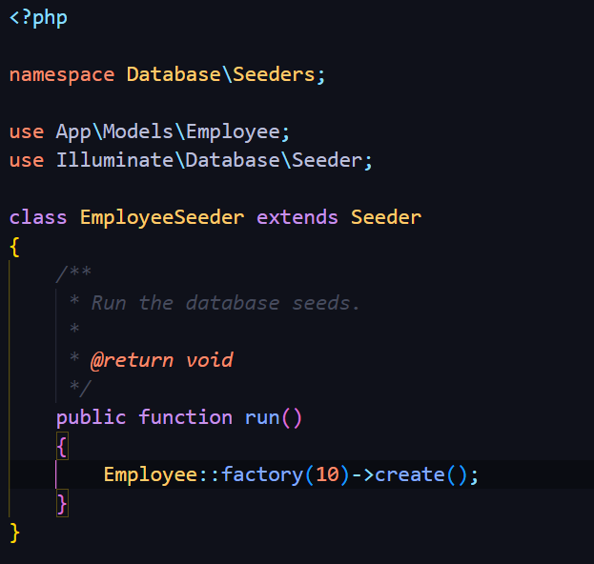

(Note: Don't forget to add use App\Models\Employee;)

1. Run the Seeder  
   php artisan db:seed --class=<seeder_name> (for Employee model seeder name will be EmployeeSeeder)

Finally 10 test data will be added to the database.

## **Objective 3**

Check Kushal Sir’s online video

## **Video Resource by Kushal Sir**

* Laravel 11 Class -Recorded on 24th June 2024

|  |
| --- |
| <https://youtu.be/zyiozjn7dkg> |

# **Artificial Intelligence Lab**

We predicts - the final lab question will be similar to this class test question below:

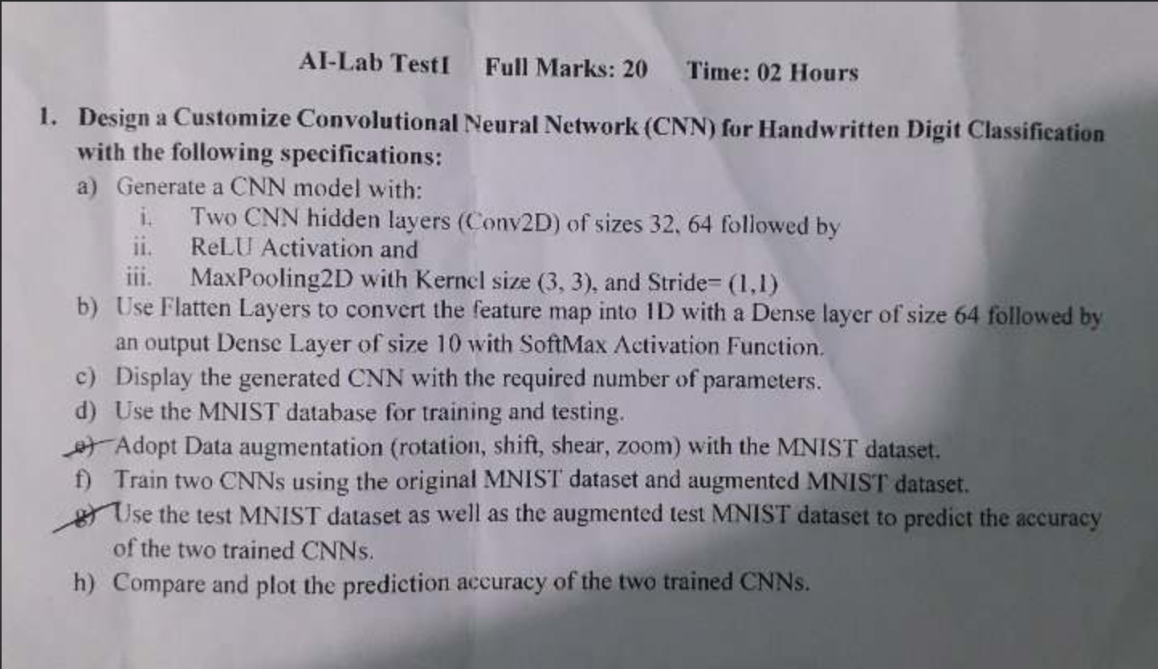

## **Solution Notebook**

|  |
| --- |
| <https://colab.research.google.com/drive/1ZM8PAWcfSYhPk3_4VZ8KJI79cvuBaD?usp=sharing> |

Distributed DBMS Lab

## **Installation**

1. Download and Install Docker Desktop (Personal):

|  |
| --- |
| <https://www.docker.com/products/docker-desktop/> |

1. Run Docker Desktop
2. Create a new directory anywhere (eg: /home/user/hadoop or E:\hadoop)
3. Open terminal from within the newly created directory.
4. **Run the command below to download the container:**

|  |
| --- |
| docker run -p 9870:9870 -p 8088:8088 -v .:/home/hadoop/data -it --name=hadoop macio232/hadoop-pseudo-distributed-mode |

1. Done.

## **Work**

1. Start the container:

|  |
| --- |
| docker start hadoop |

1. Get inside the container:

|  |
| --- |
| docker exec -it hadoop /bin/bash |

1. Done.

## **Note toTroubleshoot**

* If the container exits early, then delete the container using docker desktop or docker cli and run the command in step 5 of installation again.
* The created directory is mapped to the container in /home/hadoop/data for handling data communication.
* The container is an Ubuntu 16.04 OS, so most linux commands will work.

## **Resources to Learn More**

1. <https://medium.com/geekculture/hdfs-commands-cheat-sheet-1cd7bf22e795> (for command)
2. <https://www.youtube.com/watch?v=qgBu8Go1SyM> (word count)
3. <https://www.tutorialspoint.com/hive/index.htm> (hive QL commands)

# Cryptography Lab

|  |
| --- |
| <https://github.com/Ankar-Kumar/cryptoLab> |

<https://github.com/alaminkawsar/4Y2S-LAB/tree/master/Cryptography>

<https://github.com/Nadim-Mahmud/Cryptography-Lab>

<https://github.com/SahruzRiyad/4Y2S_LAB>

<https://github.com/Anik-Modak/CSE4Y2S_Lab>

https://github.com/Wbaidur-Rahman/4-2_Lab